Exercise 21: Route (ResourceID)

Objectives and Outcomes
Route parameters allow you to define dynamic segments in your route paths that can be accessed as props within the rendered component.

Exercises
- Create a list of users and display their details upon clicking on the user's ID
const users = [
{ firstName: "John", lastName: "Done", age: 25 },
{ firstName: "Mary", lastName: "Thompson", age: 35 },
{ firstName: "John", lastName: "Smith", age: 30 },
{ firstName: "Emily", lastName: "Johnson", age: 25 },
{ firstName: "William", lastName: "Davis", age: 34 }
];


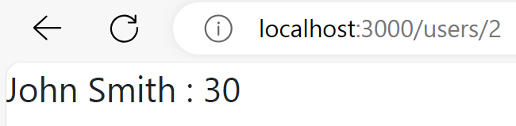
- Create a list of dishes and display their details upon clicking on the dish's ID
"dishes": [
{
"id": 0,
"name": "Uthappizza",
"image": "images/uthappizza.png",
"category": "mains",
"label": "Hot",
"price": "4.99",
"featured": true,
"description": "A unique combination of Indian Uthappam (pancake) and Italian pizza, topped with Cerignola olives, ripe vine cherry tomatoes, Vidalia onion, Guntur chillies and Buffalo Paneer."
},
{
"id": 1,
"name": "Zucchipakoda",
"image": "images/zucchipakoda.png",
"category": "appetizer",
"label": "",
"price": "1.99",
"featured": false,
"description": "Deep fried Zucchini coated with mildly spiced Chickpea flour batter accompanied with a sweet-tangy tamarind sauce"
},
{
"id": 2,
"name": "Vadonut",
"image": "images/vadonut.png",
"category": "appetizer",
"label": "New",
"price": "1.99",
"featured": false,
"description": "A quintessential ConFusion experience, is it a vada or is it a donut?"
},
{
"id": 3,
"name": "ElaiCheese Cake",
"image": "images/elaicheesecake.png",
"category": "dessert",
"label": "",
"price": "2.99",
"featured": false,
"description": "A delectable, semi-sweet New York Style Cheese Cake, with Graham cracker crust and spiced with Indian cardamoms"
}]

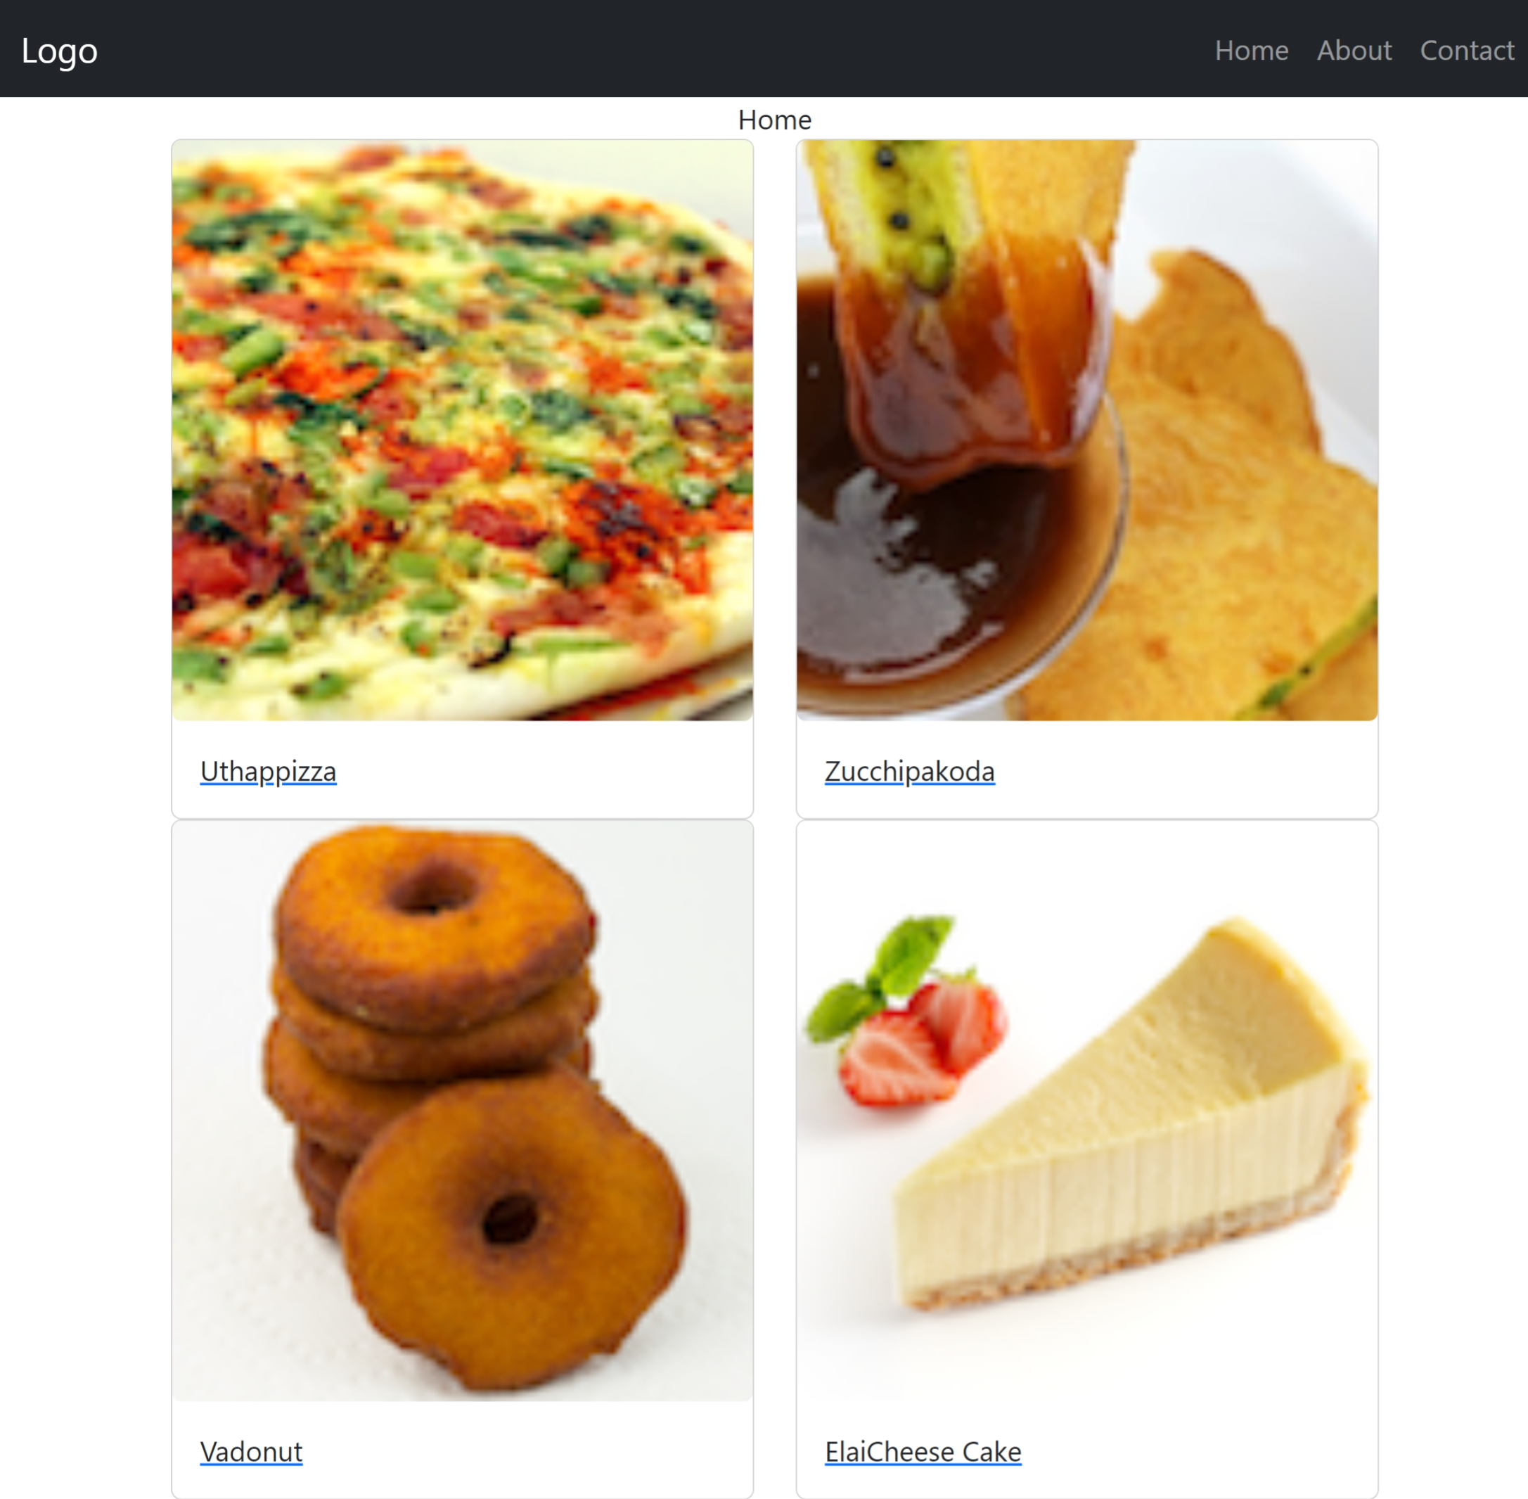

Conclusion
In conclusion, handling resource IDs in routes with React Router can be accomplished using route parameters.

